Update the Page layout For Account

Page Layout Change for Admin (Account business layout --> AccountFutureInsure)(Object --> Account)

latest Claim going to be on Top.(change by page layout🡪 short in Ass. Order)

Account Page related Section Updated, now Policy, Claim and other fields are Showing on Account Record page

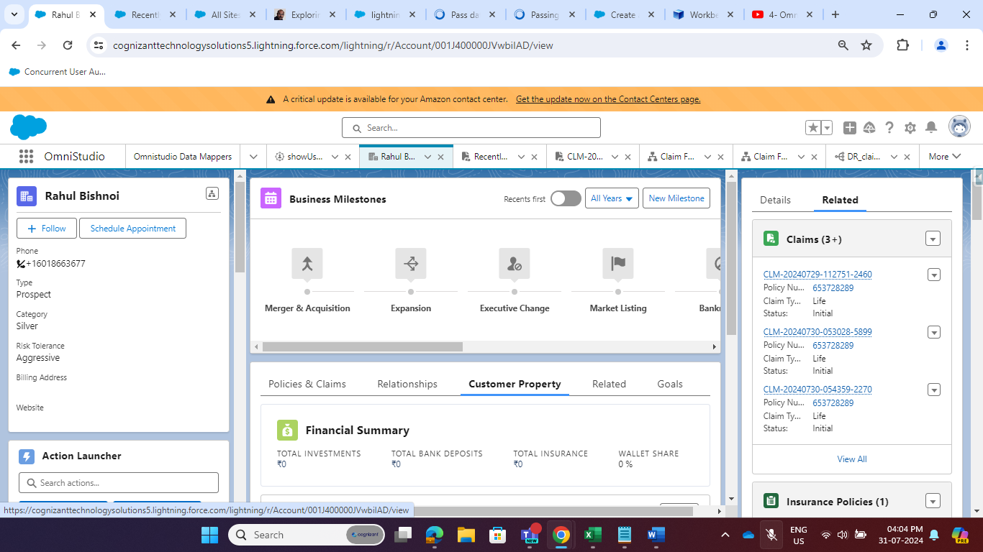

Update the Page layout For voice Call

Lightning Record Page change for voice Call (voice call record page --> futureInsurance)

Public Site --> Digital Human (working conversation?) --> Incoming Call (SCV) --> Customer 360 --> Claims List --> Click Claim created by Digital Human --> (

Not working detail page

) --> Click Claim Intake Button --> Guided Journey (

no prefilled data right now

)

Update the Page layout For voice Call

Page Layout Change for Admin (voice call layout --> voiceFutureInsure) (Object --> voice call )

According to the requirement I Update the OmnniScript(Claim Details)

OmniScript(Claim Form) --> remove lookup Policy Number, Remove extra Telephone Number, remove initiation date from Mandatory Field to non-mandatory, Name Insured--> Filled with Account Name, Remove prefix and suffix field, remove extra State Field. Created One filed for Country(in address Section)

Policy Insurance --> created BirthofDate Field and this is populated on Omniscript.

IP for Filling the Data into Omniscript(Claim Details)

Created IP for Pre-fill the data into Omniscript(Claim Details)

IP Name: ClaimwithAccount

Step1: Added Two Data Mapper Extract

Name: DRE_ClaimDetails and DRE_ClaimDetailsWithAccount

DRE_ClaimDetails

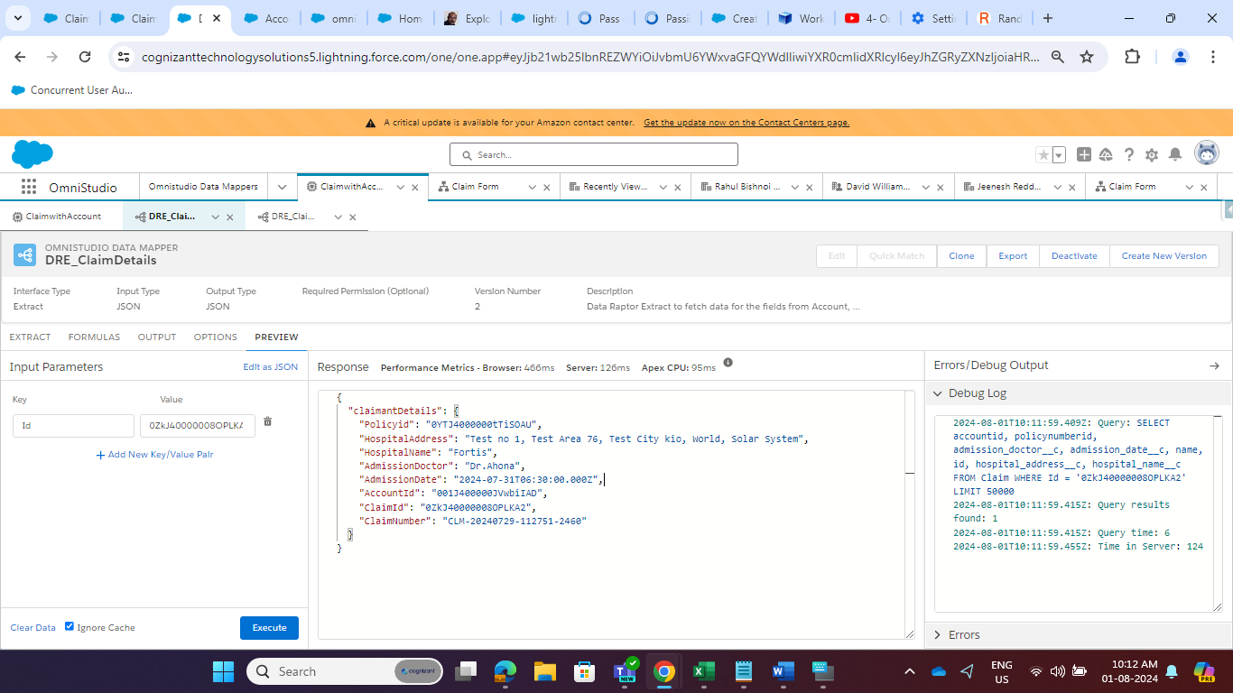

RE_ClaimDetailsWithAccount

Use these three Id and fetching all required data to fill the OmniScript.

Final JSON Tree we are getting from IP in Response Action

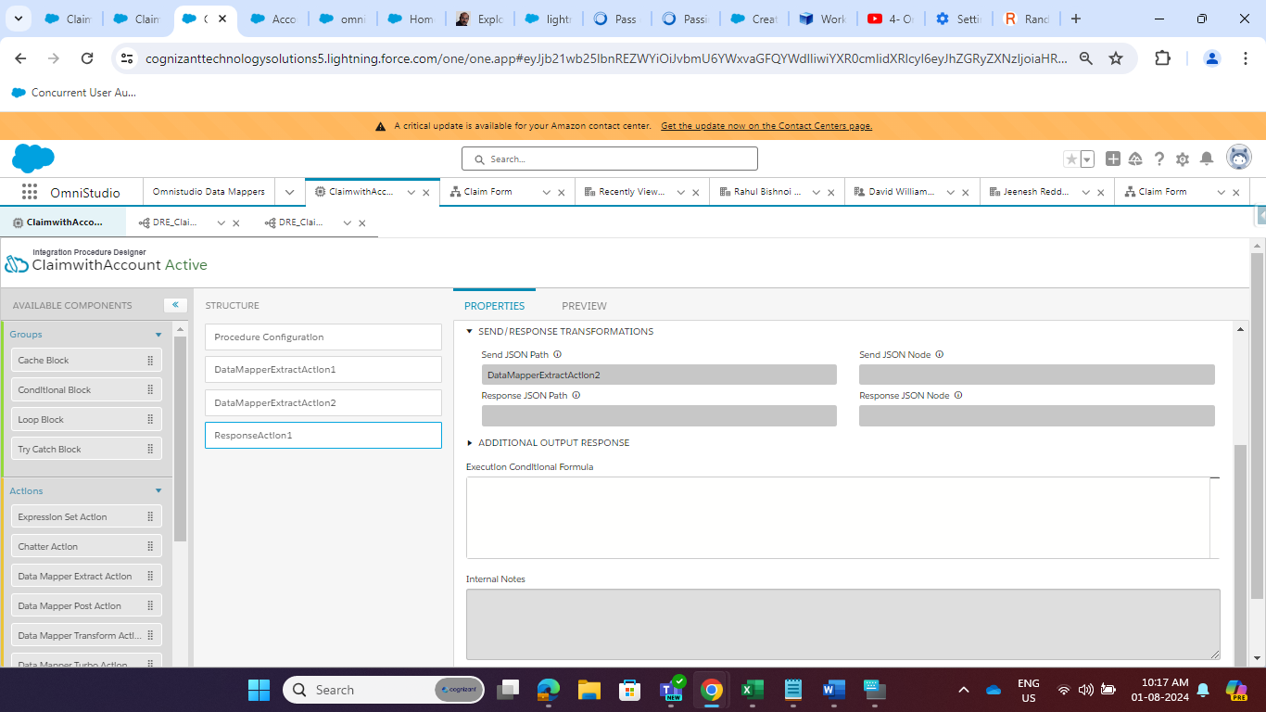

At end we have to map the data to Omniscript so we have to use Map ContxtId with our RecordID

Under Remote Properties we have to add extra Payload (Id 🡪 %ContextId%)

Then added one Action Button on Claim Page to Show the PerFilled OmniScript(Claim Form)

Final OmniScript Is Going to Look Like this…

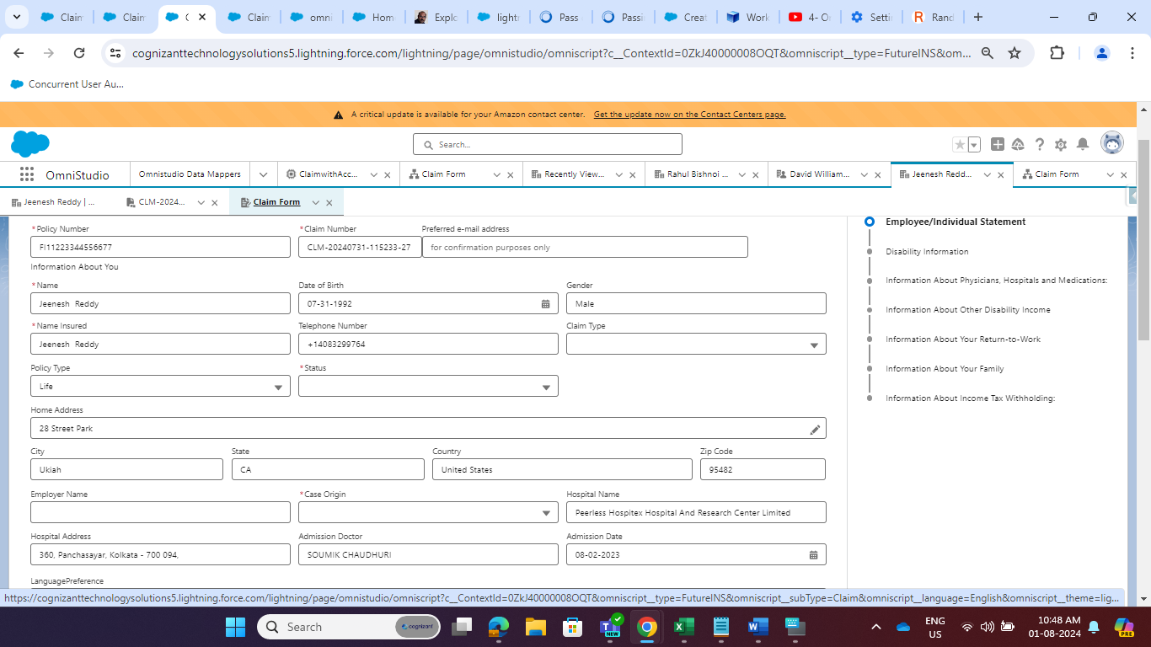

Best Practice we can done it by Data Mapper.

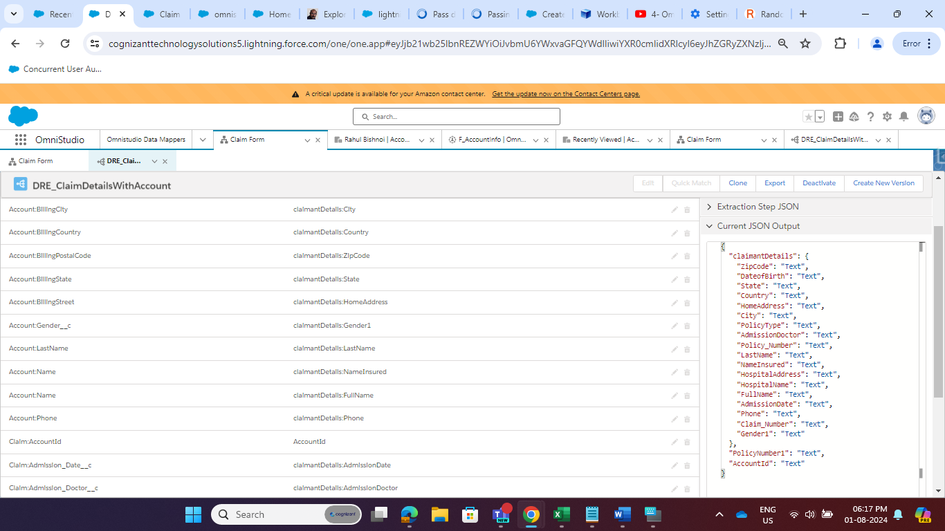

For Testing I created one new Account David Williamson Account (Business Type) with Phone Number +12518666806.

Added new Field to Claim Object to Store records.

Disability Date

Status = Draft

Case Origin = Phone

Employer Name (on Claim Object)

types of coverage (DHuman First Question) (should be in Picklist in place of Check Box in Omniscript)

Hospital Details (these details are going to be store in Claim Object)

Telephone No.

Claim Type (Draft) From AWS

Name Insured (Benificiary Name) changed

Employeer Name () From AWS

Need to be prefilled at Claim Intake (Claim Form)